Farming (Crops and Enemies)

Summary
A Looter Shooter with Farming

Features/Mechanics
Character Mechanics:
- Melee Attack - A melee attack for dealing damage to Enemies/World Elements
- Drag & Drop Inventory - For storing grown crops and fighting equipment such as Weapons/Armour
- Armour - 3 armour slots, Head, Chest, Greives. Each gives an armour bonus; a full set gives additional bonus. Armour reduces incoming damage.
Enemy Mechanics:
- 3 Core enemy types - 3 core enemies though they are tweaked Via a data asset system to add additional variation.
- Melee attack – A melee attack to deal damage to the player.
- Ranged Attack – A range attack to deal damage to the player.
Level Mechanics:
- A gate to enter the wilds – A gate that the player can open and close to leave the safety of the farm and village and go out into one of the wilds biomes.
- Destructible refuse – destructible elements that drop gold and very very rarely items.
- Farm crop plots – plots for growing crops.
- Seeds – Exotic seeds dropped by biome bosses.
- Shop – A shop to sell & buy crops & equipment.

Game Play & Design

Win Condition(s)
Defeat all 3 biome bosses. Then paying to evacuate the island.

Lose Condition(s)
The game will have no final lose state, the player can die to enemies spawning back in the farm losing a set amount of gold as a respawn fee

Gameplay Overview
The game has 2 core game loops which supplement each other, these are detailed in more detail in the technical design document.
The first focuses primarily on the farming element, the player can plant & Harvest crops which they can then sell. This currency can then be used to buy additional seeds or equipment for adventuring.
The secondary loop focuses on the adventuring, the player can leave the safety of the village out into one of the 3 hostile biomes, within which they can fight endless waves of enemies until the biomes boss spawns, killing this boss will give access to a new seed on the farm.
The player final goal is to kill all 3 world bosses, but to do so they will need to gain better equipment through farming either crops or mobs for gold to buy better equipment.

Gameplay Inspirations
Stardew Valley:
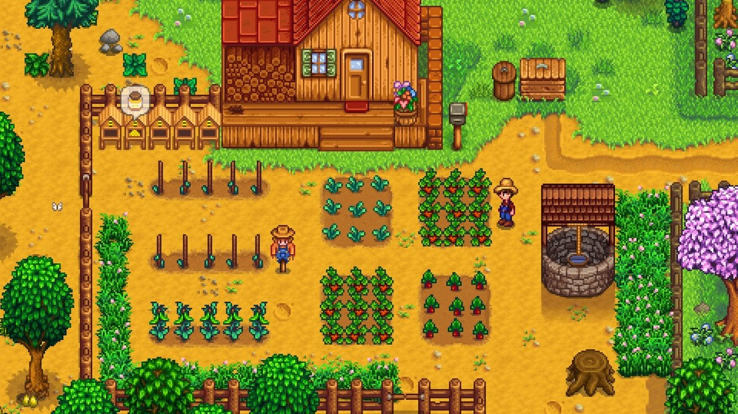
Risk of Rain 2:
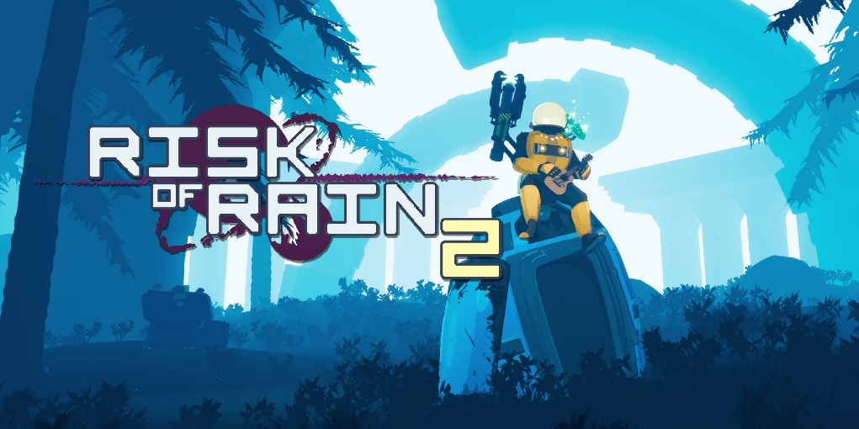

Interface
The player will have a Health and Stamina bar in the bottom left corner and a gold icon with their current gold amount in the top left.
The crop placement Ui will display all crops in the game with the buttons disabled for crops the player doesn’t own.
The shop Ui will have a section at the bottom to sell items, and a section above for buying equipment.
The Inventory UI will be a classic CRPG drag and drop inventory.
Controls
- WASD – Directional Movement
- Mouse X & Y – Camera 360 control
- Space – Jump
- Left Click – Attack/UI Interact
- Right Click – Block
- E – Interact
- Esc – Pause

Art Style
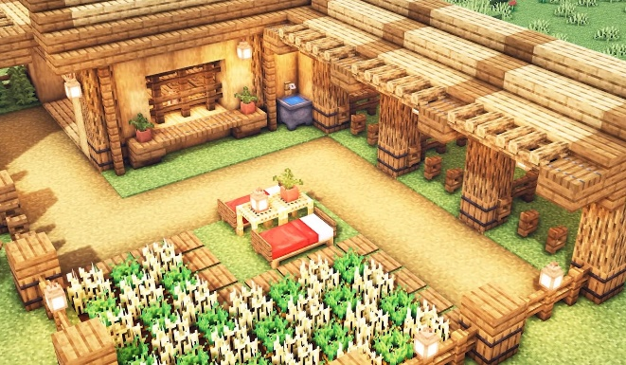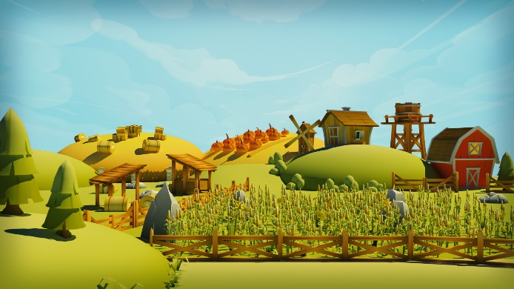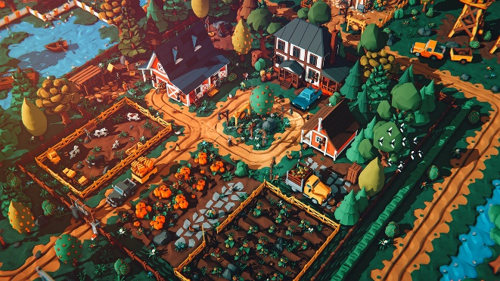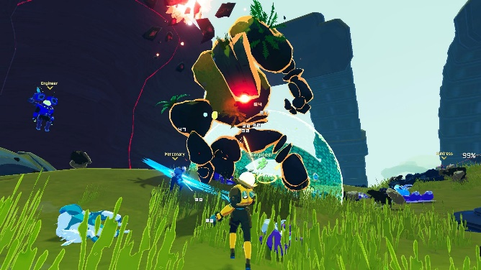

Sound
The game will have a number of Sound elements, many world elements as well as a number of UI interaction sounds.
Major Sounds Needed:
- Background Sounds for biomes and level elements i.e. Sea
- Enemy Attack Hit & Idle sounds
- Character Damage sounds
- Boss defeat sounds for serotonin
- Selling and buying sounds
- Harvest crop sounds
There will be many more but this is a concise list of the major elements

MoSCoW

Must Have
Player Basic Systems
Player Melee Attack
Farm Plots
Basic enemy
Basic inventory

Should Have
Full complement of enemies
Drag and drop Inventory
Shop
Additional Seeds
Armour sets & Weapons
Enemy Engagement Manager

Could Have
Sellable items – Items that only exist to be sold for gold, i.e grandads rusty old watch, a diamond ring u stole from an old woman etc.
NPC – NPC’s for story element, e to interact, click to skip dialogue

Won’t Have
- Crops wilting - The crops wont wilt, once grown they will wait until the player harvests them
- Repeat planting cost - Each plot will have the crop set by the player, it will then grow to harvest, from there the player can harvest the crop or rip it out, if they harvest they gain the amount harvests and replant the same crop, if they rip out they loose the crop and can change the plot to a different crop
- Paid area gates – The player will be able to wander to any of the three biomes from the beginning.

