Design Documentation
Character Design Sheet
Summary
A flying character with upgradable elements in conflict with a number of basic enemy types.
Features/Mechanics
Player Flight System - a flight system as the core movement mechanic.
Basic & Heavy Weapon - 2 basic weapon types for combating the enemies.
Inventory & stat effecting pickups - A inventory system inspired by Skyrim with pickups for collecting items and health.
Enemies - A series of basic enemies with various weapons and a final boss enemy.
Energy system - An energy, Mana system for firing weapons and tracking health.
Wind - A wind system where blocks of wind are spawned through the level effecting the flight mechanic.
Interface
The game will have a basic UI showing just the essential elements for gameplay, those being the energy/health bar, effects indicator for wind, damage .etc as well as an aim reticule.
This will be the main interface for the prototype, the bottom bar will show energy/health and the top right corner will show the current status effects such as wind, there will also be some screen effects for flight boost and damage.
This will be the inventory screen, it will appear on top of the main display and pause the game while open, it will list all items the player has collected with an icon next to those that are equipped.
Controls
WASD - Basic Movement controls
Space - Jump/Fly up
Ctrl - Crouch/Fly Down
Shift - Run/Flight Boost
Left Mouse - Fire Main Weapon
Right Mouse - Aim Weapon
Scroll Wheel - Fire Alt Weapon
Tab - Open Inventory
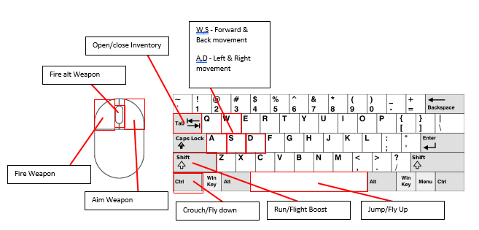
Art Style
The prototype will have a more realistic leaning art style
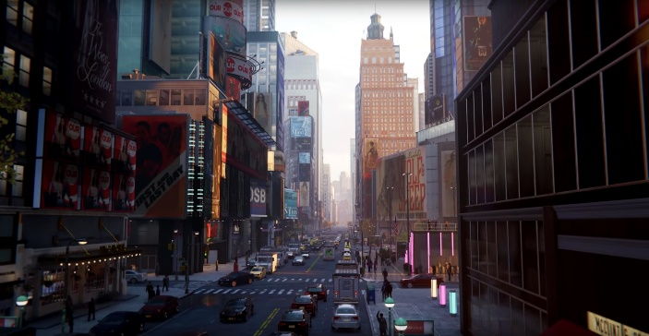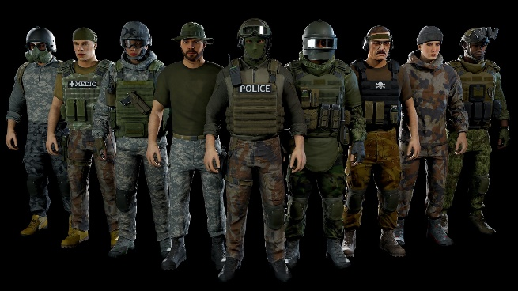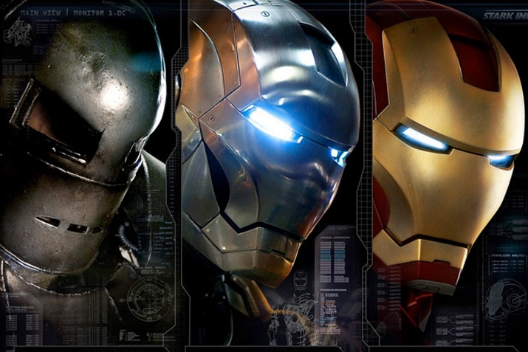
Sound
The game will have SFX for shooting each weapon, launching flight, landing, flight boost & Wind to name some of the main elements.
MoSCoW
Must Have
Flying System
Basic & Heavy Weapon
Inventory & Stat Effecting Pickup System
Basic Assault Enemy
Checkpoint Race System
Energy/Mana System
Should Have
Additional Player Weapons & Pickups
Additional Enemy Types
Wind System
Could Have
Boss Enemy
Melee Combat
(Probably) Won’t Have
Map System
Non-combative NPC’s (Pedestrians, Cars)
Fetch Quest System

One sheets
Below are some One sheets for the primary player character, Basic enemy and Boss enemy documenting their basic mechanics and inspiration.
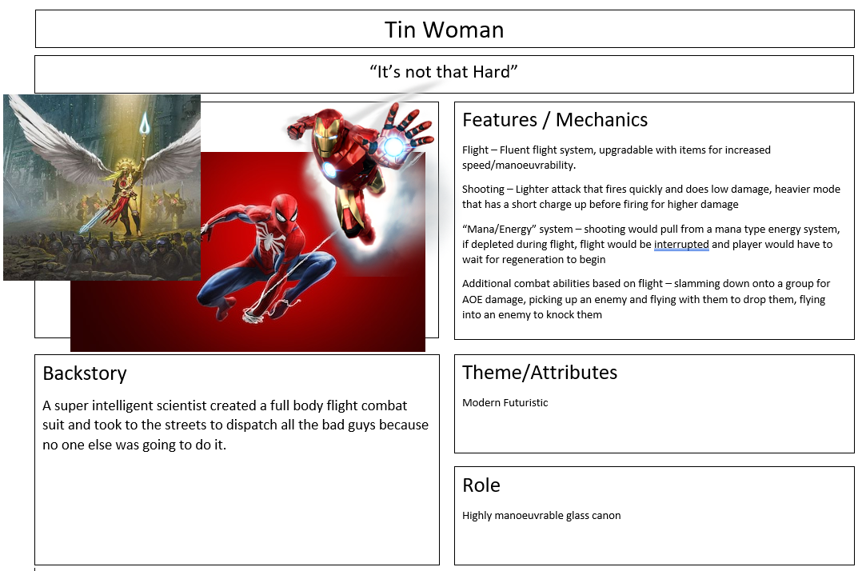
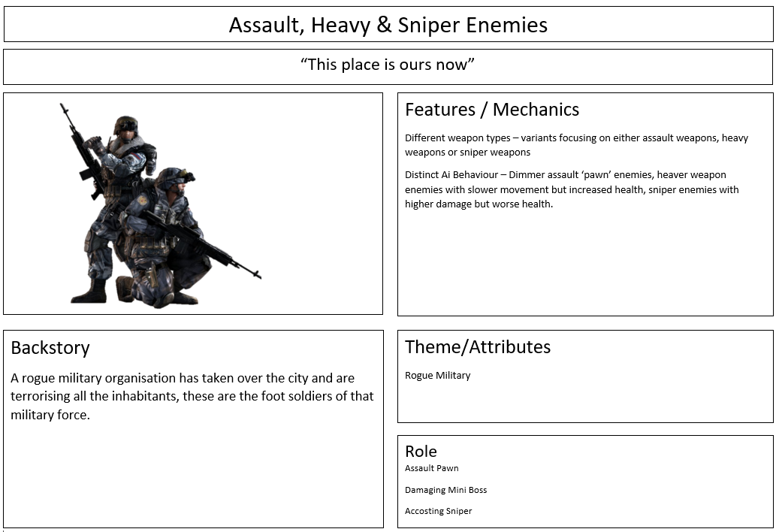
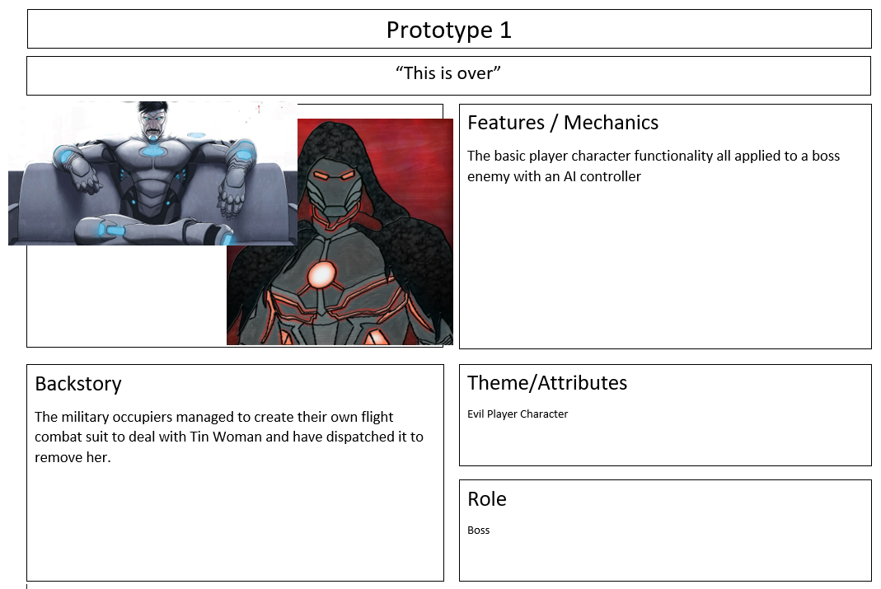
Thematic Resonance matrices
Player Character
 | Mechanics |  |  | Correlation %
Themes | Flight | Energy Weapons | Energy System
Sci-Fi | 1 | 1 | 1 | 100
Futuristic | 1 | 1 | 1 | 100
Electricity | 0.5 | 1 | 1 | 83
Correlation % | 83 | 100 | 100
This is a thematic resonance matrix for the core player characters and their abilities, all but flight/electricity have full marks for correlation with the other 2 being slightly off but still enough within the theme to fit.
Enemy Characters
 | Mechanics |  | Correlation %
Themes | Assault, Rocket & Sniper Weapons | Attack on sight
Military | 1 | 1 | 100
Foot Troops | 1 | 1 | 100
Evil | 0.8 | 1 | 90
Correlation % | 93 | 100
This table focuses on the enemy characters, the 3 weapon types and their auto response of attacking on sight. The main themes for these enemies are, military, foot troops and evil, as they’re the base foot militia of a private army that’s taken over the city. All mechanics have high correlation with the themes and vice versa, the only one not at 100% is Evil/Weapons which is a hard one to decide on as there’s a lot of debate surrounding the topic.
Level Elements
 | Mechanics |  |  | Correlation %
Themes | Wind | Checkpoints | Pickups
Realistic | 1 | 0 | 0 | 33
Arcady | 0.5 | 1 | 1 | 83
Free Form | 1 | 0 | 1 | 66
Correlation % | 83 | 33 | 66
This table focuses on the level elements, as you can see this it is slightly less aligned than the previous ones, the issues being with the realistic art theme and the checkpoint system. It may be worth considering scraping the checkpoint idea as it doesn’t conform very well with the rest of the project, which would bring the realistic theme up to a workable 50%.
Prototype Video
https://youtu.be/m29Ppbyj00o
Technical Documentation & Plan
Core Loop
Define the main activities that the player will perform in the prototype.
Action(s): Free Form Flight, Enemy Combat, Race Minigame
Reward(s): Pickups, Character Progression
Expansion(s): Race Minigame
Core Loop Diagram
N/A – Due to the nature of the project there won’t be a complete game loop.
Actions
The main actions the character will perform to play the game.
Action | Description | How does the player perform and complete this action
Free Form Flight | An unrestricted flight system as the core movement system | The player flies around as they wish and for as long as they wish.
Enemy Combat | Enemy combat as the core gameplay mechanic | Enemies will spawn throughout the sandbox play space for the player to defeat.
Rewards
The rewards that the player will be received when they successfully complete the actions.
Reward | Description | How and when does the player earn this reward
Pickups | A pickup system for collecting items and health | Spawned randomly or dropped by enemies
Character Progression | Picked up items can be equipped to improve the players overall stats | Equipping collected items through the inventory system.
Expansions
The expansions that the player will obtain to continue playing the game.
Reward | Description | How and when does the player use this expansion
Race Minigame | A race minigame where the player can fly through checkpoints to try get the best time | The player can activate the race from a starting point and then progress through the checkpoints to the finish.

Game Rules
Win
The player Wins when they defeat the final boss of the sandbox.
Lose
The player loses each time they die however they can respawn with minimal loss.
Death / Respawn
When the player Dies they will be respawned at the nearest spawn point to continue their fight.
Lives
The game will have no Lives system
Energy
The player has an energy pool from which they can draw ammo for firing weapons and health, as they take damage the pools maximum size is decreased limiting their ability to fire weapons, they can find pickups to repair themselves and increase the pools size.

Camera
The game will have a third person camera with a perspective of looking over the player characters shoulder, there will also be a zoomed in version where the camera comes level with the player head for a more first person type view.
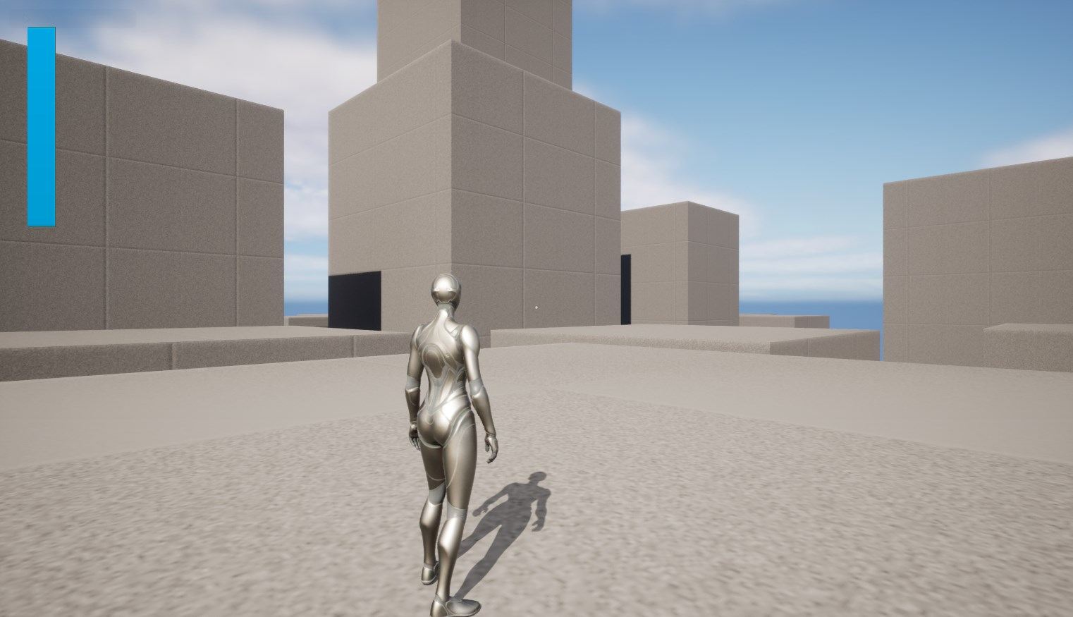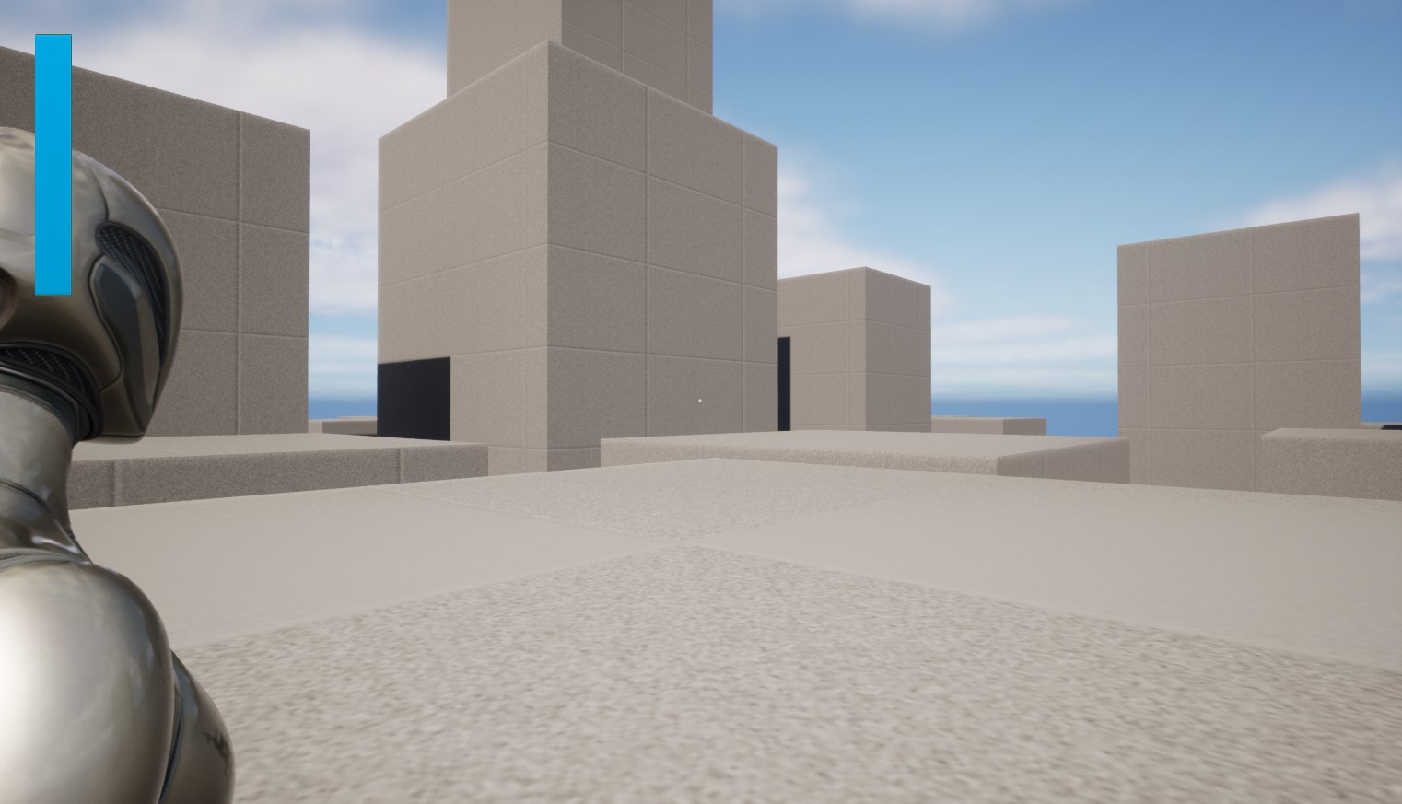

Play Space
Map(s)
The player will have a freeform sandbox level to play around in primarily designed to look like a modern city.

Game Entities
Game Entity | Description | How does the player use/interact/control this entity? | How does this entity work?
Player character | The core Player Character | The players inputs control this entity | The entity receive inputs from the player controller which effect its movement, attacks and any other gameplay mechanics within the project.
Assault Enemy | The basic enemy Type | The player interacts with this entity during combat | The assault enemy sense the player, going on alert, then begins firing at the player, taking cover when they’re low on health.
Heavy Enemy | The tougher enemy type | The player interacts with this entity during combat | The Heavy enemy fires a more slow rate of fire weapon after sensing the player and refuses to take cover as they are tougher with more health.
Sniper Enemy | The highest damage enemy | The player interacts with this entity during combat | This enemy immediately finds cover to being shooting a slow rate of fire medium damage weapon.
Boss Enemy | The final Boss | The player interacts with this entity during combat | The final boss would reflect the players abilities with a more complex combat AI. Note: This enemy may not be included in the final artifact.
Item Pickup | Pickups for stat effecting items | The player can collect this entity for its effect | When collected by the player, adds an item to the players inventory which can then be equipped
Repair Pickup | Pickup for health | The player can collect this entity for its effect | When collected by the player, repairs up to a set amount of damage received by the plyer
Energy Pickup | Pickup for ammo | The player can collect this entity for its effect | When collected by the player, gives a sudden energy replenishment.

Systems and Mechanics
System/ Mechanic | Description | How does the player use/interact/control this entity? | How does this system or mechanics work?
Wind | Wind that effects the player flight system | This entity effects the players movement characteristics | Wind will spawn/activate at points through the level, this will effect the player flight system by adding velocity in whichever direction the wind is blowing, the player can fly out of these to avoid them.
Energy System | A mana type energy system | The player draws from this energy pool when firing their weapons and flying, the player health is recorded by the pools maximum size decreasing. | When the player boosts or fires their weapons energy is used up from their pool, it regenerates when not in use and can be quickly resupplied with pickups. When the player takes damage the pools maximum size decreases, this can only be repaired with a pickup. (See Flowchart)
Inventory | A system for managing collected items | The player uses this to view and alter their selected items | When the player collects items they will be added to this system, from which the player can equip them to alter their stat such as movement speed, fall damage, equipped weapons.
Checkpoints | A checkpoint that can be connected to others to create a racecourse | The player can enter these to trigger the next and complete a timed race challenge. | All checkpoints will be placed in the level and linked to each other sequentially, as the player passes through one it will deactivate and trigger the next and so on until the final checkpoint.
Respawn | A system of respawning the player | Upon player death a respawn point is selected for them to begin from | Player starts will be placed throughout the level, upon death these will be cycled through to find the one nearest the players death point to use as a respawn point. (See Flowchart)

Energy System Flowchart
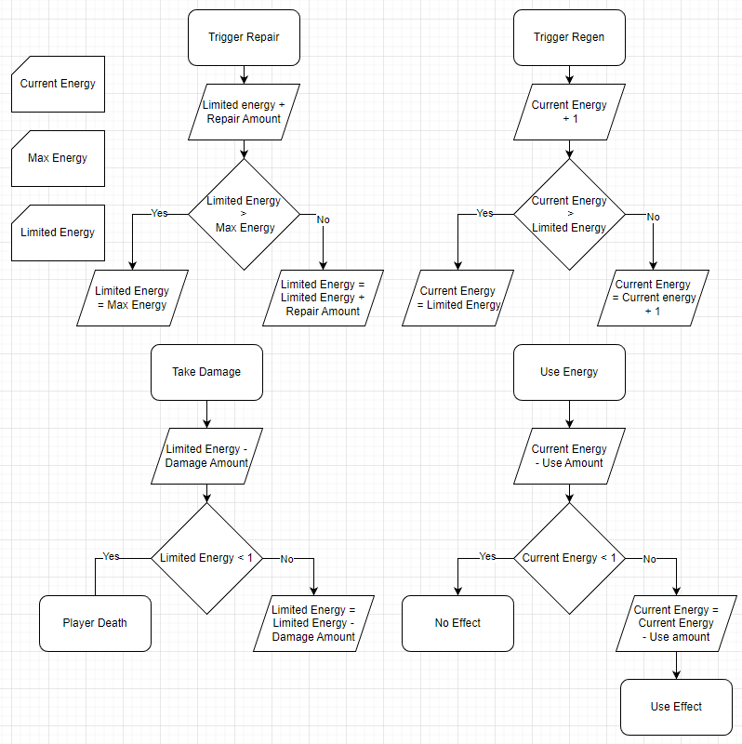
Respawn System
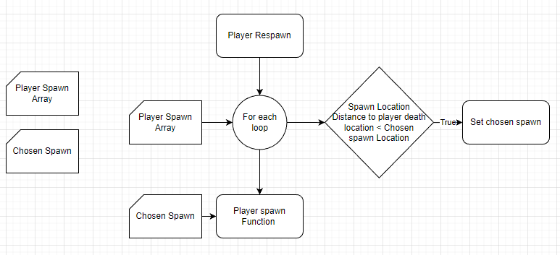

Week | Action | Potential Issues | Safe Guards
Week 6 | Complete the Pickups & all Basic Systems as well as begin work on the level elements. | No Major issues Predicted. | N/A
Week 7 | Start basic AI implementation with future subclasses in mind. Finish tidying up the Animation. Finish level elements | AI may take more time than anticipated to implement which could push back other features. | AI will be revisited in Week 9 meaning smaller issues can be postponed.
Week 8 | Begin work on the inventory system tying into the existing pickup system. Finish secondary weapon types. | Existing weapons are Tied into The player character, not separate entities. | Ensure Weapons are separated into a class system in week 6.
Week 9 | Complete AI for both subclasses and assess viability of boss enemy. | Boss enemy may be unviable. | Enough other enemy classes should have been completed to meet the brief.
Week 10 | Tidy up project, Level Meshing, UI finalisation, Sound & SFX. Play Testing. | Level meshing may take up too much time. | Attempt to find and use a premade level.
Week 11 | Polish & Play Testing, Hand in the Project. | Earlier elements may remain unfinished. | Any elements that run over should be able to be dealt with in this week.
Action Plan

